Name: Farukh Haleem

Student No: 16648

Github url: https://github.com/farukhhaleem/metEirannProject

**Main Activity**

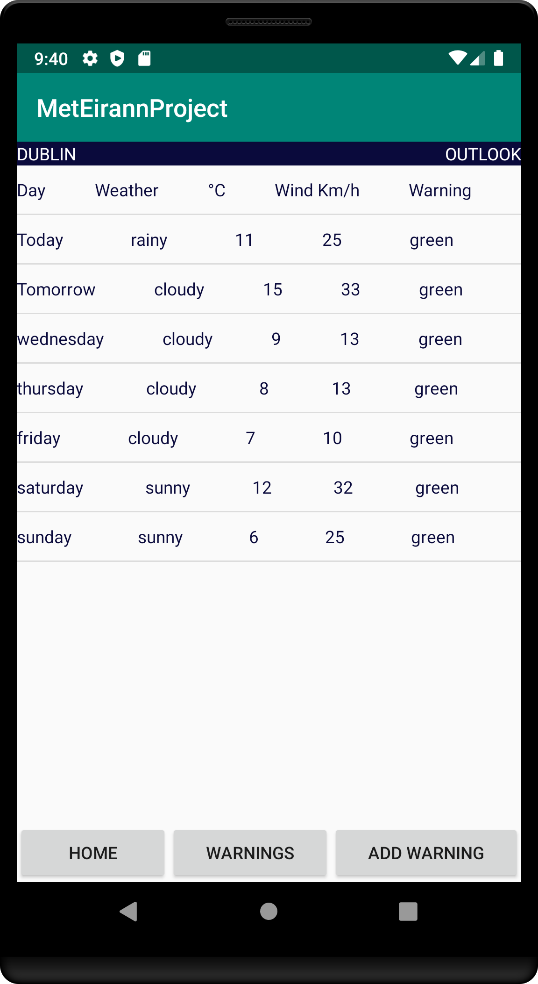

**Warning Activity**

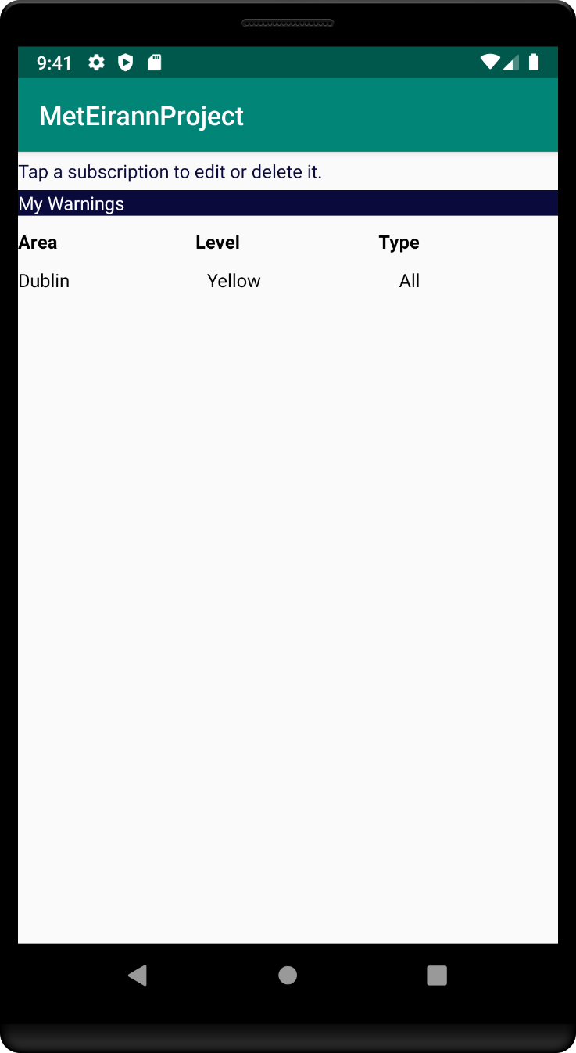

**Add Warning Activity**

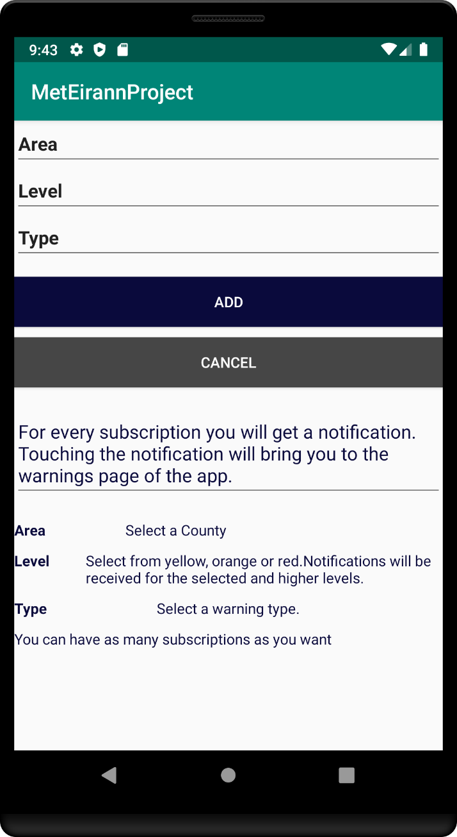

**Edit Warning Activity**

